## [primefaces]DataExporter匯出數值欄位無法直接加總

Shared by: Gilbert Lin

Problem:

dataExporter匯出欄位皆為通用格式無法直接加總欄位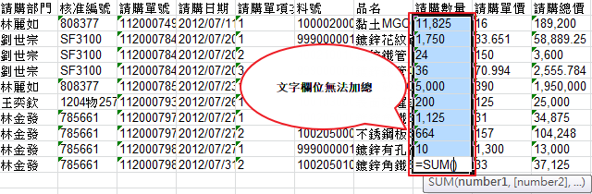

Solution:

利用 dataExporter的 postProcessorer event

**requisitionList.xhtml**

<h:commandLink rendered="#{requisitionList.resultList.size() !=0}">

<h:graphicImage width="30" height="35" library="images" name="excel.png" style="vertical-align: bottom; border-style: none" />

<h:outputLabel value="匯出報表"/>

<p:dataExporter type="xls" target=":approvalNoListForm:dataList" fileName="#{selectItems.genFileName('requisitionList')}"

postProcessor="#{requisitionList.postProcessXLS}"

/>

</h:commandLink>

**RequisitionListController.java**

/**

* 針對匯出Excel客製化處理

* @param document

*/

public void postProcessXLS(Object document) {

HSSFWorkbook wb = (HSSFWorkbook) document;

int[] numericColumns = new int[]{7, 8, 9};//請購數量, 請購單價, 請購總價

ExportUtil.translateXlsNumericFields(wb, numericColumns);

}

**ExportUtil.java**

/**

* 針對指定欄位轉換為數值欄位

* @param wb

* @param numericColumns 指定欄位

*/

public static void translateXlsNumericFields(HSSFWorkbook wb, int[] numericColumns){

HSSFSheet sheet = wb.getSheetAt(0);

int rows = sheet.getPhysicalNumberOfRows(); //取得所有的Row

for(int r=0; r<rows; r++){ //掃描所有的Row取得資料

if(r == 0){//header 不處理

continue;

}

HSSFRow row = sheet.getRow(r);

for(int c=0; c < row.getPhysicalNumberOfCells();c++) {

for (int i = 0; i < numericColumns.length; i++) {

int columnIdx = numericColumns[i];

if(c != columnIdx){//非數字不處理

continue;

}

HSSFCell cell = row.getCell(c);

String sV = (String) cell.getStringCellValue();

sV = StringUtils.replace(sV, ",", "");

if (StringUtils.isBlank(sV)){

sV = "0";

}

Cell cell_new = row.createCell(c);

cell_new.setCellValue(Double.valueOf(sV));

String format = "#,##0.000";

cell_new.getCellStyle().setDataFormat(HSSFDataFormat.getBuiltinFormat(format));

cell_new.setCellType(Cell.CELL_TYPE_NUMERIC);

}

}

}

}

Ref.

<http://www.primefaces.org/showcase-labs/ui/exporterProcessor.jsf>